# “Student management system”

### A Project report submitted

**In the partial fulfillment the award of degree of**

**BACHELOR OF TECHNOLOGY**

**IN**

**ELECTRONICS AND COMMUNICATION ENGINEERING (2022-2023)**

**BY**

**M. Jaswanth – 21180136008**

**Shaik .Thalha - 211801390010**

**P. Hari krishna – 21801390006**

**M. Sai krishna – 211801360018**

**N. Abraham lincon – 211801360001**

**Under the esteemed Guidance of**

**Mrs. G. Rama Devi, M.Tech,(Ph.d),Asst. Professor**

**CENTURION UNIVERSITY SCHOOL OF ENGINEERING AND TECHNOLOGY**

**Rollavaka village, Tekkali mandal 535003**

**(2022-2023)**

**CENTURION UNIVERSITY OF TECHNOLOGY AND MANAGEMENT**

**ANDHRA PRADESH**

**(2019-2023)**

##### ELECTRONICS AND COMMUNICATION ENGINEERING

BONAFIDE CERTIFICATE

##### This is to certify that the project work entitled “STUDENT MANAGEMENT SYSTEM” is a fulfillment of project work done by Group Members for the award the degree of BACHELOR OF TECHNOLOGY in ELECTRONICS AND COMMUNICATION ENGINEERING, CENTURION UNIVERSITY OF TECHNOLOGY AND MANAGEMENT, during the academic year 2022-2023.

##### INTERNALGUIDE HEAD OF THE DEPARTMENT

##### Mrs .G. Rama Devi Mr. Lakshman sir

**Asst. Professor**

**Dept. of CSE Dept. of CSE**

**EXTERNAL EXAMINER**

**ACKNOWLEDGEMENT**

It is with at most pleasure and excitement we submit our project partial fulfillment of the requirement for the award of Bachelor of Technology.

The project is a result to the cumulate efforts, support, guidance, encouragement and inspiration from many of those for whom we have to give our truthful honor and express gratitude through bringing out this project at the outset as per our knowledge.

I convey my special thanks to our project **Guide Mrs. G. Rama Devi(Asst. Professor)** who has guided, encouraged and tremendously supported me to enhance my knowledge with present working of this project to bring out enriching the quality of project.

I express my appreciativeness to **Mr. LAKSHMAN(Asst. Professor) and Head of the Department,** who facilitated us to providing the friendly environment which helped to enhance my skills in present project.

I would also like to extend my gratitude to **Dr. K. V. G. KRISHNA MURTHY, Dean-School of Engineering And Technology, Centurion University of Technology and Management** who has helped us to attain all the requirements of the project.

I convey my sincere thanks to **Dr. RAMANA RAO, Ph. D Registrar of Centurion University of Technology and Management** who provided us with an opportunity to take on project work in well-equipped laboratories of Computer Science Department in our college.

At the outset, we thank to **Sri. G.S.N.RAJU**, beloved **Vice Chancellor of Centurion University of Technology and Management** who is the back bone by providing for completion of this project, Thank you sir.

**DECLA****RATION**

I hereby declare that the project entitled **“STUDENT MANAGEMENT SYSTEM”** submitted to the fulfillment of award the degree of **B.TECH (CSE)** in **CENTURION UNIVERSITY OF TECHNOLOGY AND MANAGEMENT**, **ANDHRA PRADESH.**

**M. Jaswanth – 21180136008**

**Shaik .Thalha - 211801390010**

**P. Hari krishna – 21801390006**

**M. Sai krishna – 211801360018**

**N. Abraham lincon – 211801360001**

Table of Contents

1. INTRODUCTION 1

1.1 Purpose 1

1.2 Scope 1

1.3 Problem Definition 2

1.4 Audience 2

1.5 Tools to be Used 2

1.6 References 2

1.7 Overview 2

2. GLOSSARY 4

2.1 Definitions 4

2.2 Acronyms and Abbreviations 4

3. SYSTEM MODEL 6

3.1 State Transition Diagram 6

3.2 Sequence Diagram 7

3.3 Use Case Diagram 8

3.4 Data Flow Diagram 9

4. FUNCTIONAL REQUIREMENT 11

4.1 User Class 1- Non Registered Users 11

4.2 User Class 2- Registered Users 12

5. NON FUNCTIONAL REQUIREMENTS 14

5.1 Security Requirements 14

5.2 Performance Requirements 14

5.3 Safety Requirements 14

6. SYSTEM EVOLUTION 15

7. REQUIREMENT SPECIFICATION 16

7.1 Product Perspective 16

7.1.1 Hardware Interface 16

7.1.2 Memory Constraint 16

7.2 Product Function 16

7.3 Database Requirement 16

7.4 User Characteristics 20

7.5 Assumptions and Dependencies 20

# 1.INTRODUCTION

The Student Management System is a comprehensive software solution designed to streamline and automate the management of student-related information in educational institutions. It serves as a centralized platform that handles various aspects of student administration, including enrollment, attendance tracking, grading, scheduling, and communication.Traditionally, managing student records and information has been a tedious and time-consuming task, involving extensive paperwork and manual data entry. However, with the advent of technology, educational institutions have increasingly embraced digital solutions like the Student Management System to enhance efficiency, accuracy, and overall effectiveness.The primary objective of the Student Management System is to provide administrators, teachers, and staff with a user-friendly and efficient tool to handle diverse tasks related to student management. By digitizing and automating various processes, the system reduces administrative burden, minimizes errors, and improves communication and collaboration among stakeholders

## Purpose

The purpose of the Student Management System project is to create a comprehensive software solution that effectively manages and organizes student-related information in educational institutions. The project aims to streamline administrative processes, enhance communication and collaboration, and improve overall efficiency in managing student data.

## Scope

The scope of the Student Management System project includes the development, implementation, and maintenance of a comprehensive software solution that addresses various aspects of student management in educational institutions.

## Problem Definition

The current problem in student management within educational institutions revolves around manual and paper-based processes, which are inefficient, time-consuming, and prone to errors. The lack of a centralized and automated system for managing student information leads to various challenges.

The identified problems indicate the need for a Student Management System that can automate and streamline administrative processes, centralize student data, improve accessibility and communication, enhance attendance tracking and performance monitoring, provide robust reporting and analytics, and ensure the security and privacy of student information. By addressing these problems, the Student Management System project aims to overcome the challenges associated with manual student management processes and improve overall efficiency and effectiveness in educational institutions.

## Audience

The Student Management System project is designed to cater to the needs of various stakeholders within educational institutions. It is important to note that the level of access and functionalities within the Student Management System may vary for each audience group. The system should provide role-based access control, ensuring that each user group has appropriate permissions and access rights based on their responsibilities and needs.

## Tools to be Used

Programming Language: HTML, CSS, JavaScript and Bootstrap for front-end.

PHP for back-end.

Database: MySQL

Platform: XAMPP

## References

Somerville, Software Engineering, 10th ed. England: Addison-Wesley, 2017

## Overview

The Student Management System project aims to develop a comprehensive software solution that efficiently manages and organizes student-related information within educational institutions. It provides a centralized platform to automate administrative tasks, enhance communication, and improve overall efficiency in student management.

**2 .GLOSSARY:-**

**2.1 Definitions:**

Email Authentication

Email authentication is a technical solution to proving that an email is not forged. It provides a way to verify that an email comes from whom it claims to be from. Email authentication is most often used to block harmful or fraudulent uses of email such as phishing and spam which has been implemented in this platform.

Interface

The interaction between a user and system running on a Web server. The user interface is the Web browser and the Web page it downloaded and rendered.

Class

Class is a blueprint or prototype that defines the variables and the methods common to all objects of a certain kind.

Attribute

A database attribute is a column name and the content of the fields under it in a table in a database.

## 2.2Acronyms and Abbreviations

HTML: Hypertext Markup Language

CSS: Cascading Style Sheet

DB: Database

DESC: Description

ER: Entity Relationship

DFD: Data Flow Diagram

**3. SYSTEM MODEL**

**3.1 State Transition Diagram**

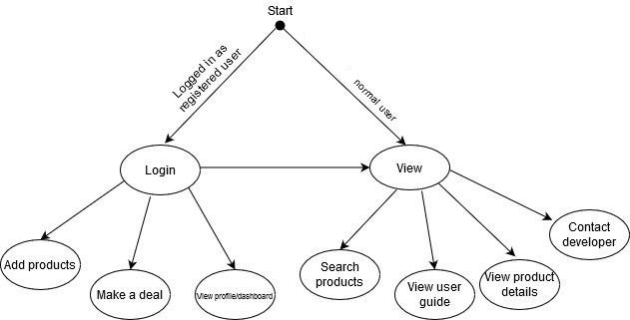

Figure 1: State Transition Diagram

State transition diagrams are used to give an abstract description of the behavior of a system. This behavior is analyzed and represented by a series of events that can occur in one or more possible states. Here the system is started with an initial state which is black dot as shown in the above figure. Logged in registered users have privilege to more states than normal users.

3.2 **Sequence Diagram**

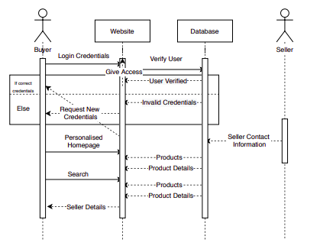

Figure 2: Sequence Diagram

A sequence diagram simply depicts interaction between objects in a sequential order i.e. the order in which these interactions take place. The above figure shows the interaction of the user with various objects of the system acted in sequence to carry out several tasks by user.

* 1. **Use Case Diagram**

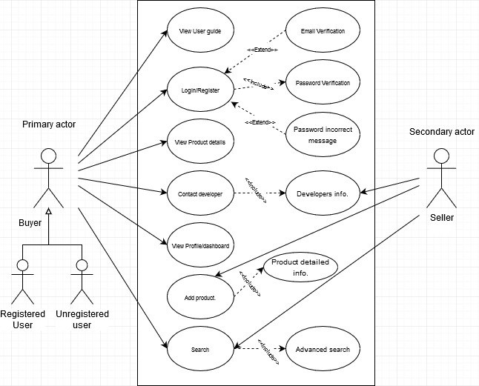

Figure 3: Use Case Diagram

A use case is a representation of a user’s interaction with the system that shows the relationship between the user and the different use cases in which the user is involved. The above figure shows the use cases of the user in the system. The user must be logged in to perform use cases like add products, view profile, view products dashboard.

## Data Flow Diagram

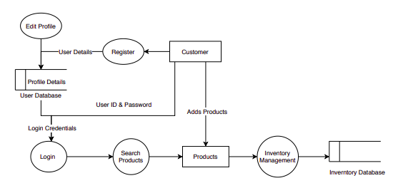

Figure 4: Level 0 DFD (Context Flow Diagram)

A data flow diagram (DFD) is a way of representing a flow of data of a process or a system. DFD describes the processes that are involved in a system to transfer data from the input to the file storage and reports generation.

# 

# 4 .FUNCTIONAL REQUIREMENT

## 4 .1 User Class 1- Non Registered Users

Functional Requirement 1

TITLE: User Registration and Authentication

Allow users (administrators, teachers, students, parents) to register and create user accounts.Provide secure authentication mechanisms (e.g.,username/password, multi-factor authentication) for user login.

Functional Requirement 2

TITLE: Student Information Management:

DESC: Capture and store student information, including personal details, contact information, and emergency contacts.Enable administrators to manage student records, such as enrollment, transfers, and withdrawals.

Functional Requirement 3

TITLE: Enrollment and Course Management:

DESC: Facilitate the enrollment process, including course selection, class scheduling, and fee payment.Allow administrators to manage course offerings, assign teachers to classes, and set maximum enrollments.

Functional Requirement 4

TITLE: Attendance Tracking:

DESC: Allow teachers to record student attendance for each class session.Generate attendance reports and provide insights into student attendance patterns.

Functional Requirement 5

TITLE: Grading and Transcript Management:

DESC: Enable teachers to record student grades for assignments, exams, and overall course performance.Generate report cards, transcripts, and academic progress reports.

## 4.2 User Class 2- Registered Users:-

Functional Requirement 1

TITLE: Login to the website

DESC: Registered users can log in to the system using their credentials. If username or email and password match then, users are logged in to the platform otherwise, error message for invalid username and password is displayed.

Functional Requirement 2

TITLE: Timetable and Scheduling:

DESC: Generate class timetables based on course offerings, teacher availability, and student enrollments.Handle scheduling conflicts and adjustments, notifying affected parties of changes.

Functional Requirement 3

TITLE: Communication and Collaboration:

DESC: Provide messaging capabilities for communication among administrators, teachers, students, and parents.Allow teachers to communicate with students and parents regarding assignments, announcements, and progress updates.

Functional Requirement 4

TITLE: Report Generation and Analytics:

DESC: Generate reports and analytics on student performance, attendance, enrollment trends, and other relevant metrics.Provide data visualization tools to facilitate data analysis and decision-making

Functional Requirement 5

TITLE: Integration with External Systems:

DESC: Integrate with other systems, such as Learning Management Systems (LMS) or authentication services, to exchange data and provide a seamless user experience

Functional Requirement 6

TITLE: View product dashboard

DESC: Users can view the number of products they have added to sell, requested to buy and been offered for the product they put on sale

Functional Requirement 7

TITLE: Contact the developer

DESC: Users can contact any developer by clicking the different social media links associated with the developer for which the information like name, email and message is required.

Functional Requirement 8

TITLE: Data Security and Privacy:

DESC: Implement robust security measures to protect student data and ensure compliance with data privacy regulations.Apply access controls to restrict data access based on user roles and permissions.

**5 . NON FUNCTIONAL REQUIREMENTS:**

The system should meet the following non-functional requirements:

**Security:**

The system have accounts for its users and only authorized users can access the system with username and password. The passwords are encrypted using a ASP.NET function.

**Reliability:**

The system are reliable to users anytime, anywhere, just need a PC and Internet Connection. Also the system work in multiple web browsers like (Chrome, Mozilla, Opera, and Internet Explorer).

**Performance:**

Easy tracking of records and updating can be done.

**User Friendly:**

The system have a friendly user interface and the system very interactive.

## 

**6.SYSTEM EVOLUTION :-**

The evolution of a student management system project can vary based on the specific requirements, scope, and resources available. However, I can provide you with a general overview of how a student management system project might evolve over time.

**Initial Stage of Website:**

Features:

General Authentication

Basic Search

**Final stage of website**:

Features:

Advanced Search

Customer Dashboard

Customer Profile

Website User Manual

**7.REQUIREMENT SPECIFICATION :-**

**External Interface Requirements**

**User Interfaces**

## The Student Management System web server must provide a user interface that will be accessible through any internet browser, the major ones being Google Chrome and Internet Explorer 12.

## Hardware Interfaces

## All components able to be executed on personal computers with Windows OS platforms and other platforms like Linux, Unix.

## Software Interfaces

## All the interfaces will be ASPX pages running within the internet browser. The SMS must integrate with the DB though SQL Interface. The system will be hosted in a web server runningon Windows Server 2005.

## Communications Interfaces

## Connections to the system will be over TCP/IP connection.

## Functional Requirements

## Log in Module (LM)

## User (admin, student and teachers) shall be able to load the Login Module in the internetbrowser. The LM shall support the user to log into the system. The login panel shall contain fields to contain a user name and a field for password. The password field shall be masked with symbols when the user types. It shall also contain a button labelled us Login. When the user clicks on Login button the username and password will be verified by database administrator and then only the user will able to use the system functions.

## Registered Users Module (RUM)

## After successful login, user shall be able to continue navigating through the website and view school/college detailed information. After successful login, user (admin, student and teachers) shall be able to update and maintain their profile, such as changing password and personal details.

**7.4** **User Characteristics**

The Kinmail platform is used by anyone that has access to the Internet and a web browser. It is assumed that the user is familiar enough with a computer to operate the browser, keyboard and mouse.

There are two types of users: Normal User (Non-Registered) and Registered User.

The normal users can use the platform to create an account, browse and search different products. They can view different products, product details, and contact website user manual.

The registered users have all privilege of normal users. They can add products, view profiles, and view product dashboard.

## 7.5 Assumptions and Dependencies :

**Users**:

We have assumed that all the users using this platform are capable of connecting their devices to the Internet and navigate the browser on their devices to the address of Kinmail website.

**Provider**:

The success of the system depends on:

* The performance of the platform is good.
* The information stored are secured and verified.
* The system is built with the perspective of HCI.

**CONCLUSION:**

Our project is only a humble venture to satisfy the needs in an Institution. Several user-friendly coding has also adopted. This package shall prove to be a powerful package in satisfying all there quire ments of the organization .The objective of software planning is to provide a frame work that enables the manger to make reasonable estimates made within a limited time frame at the beginning of the software project and should be updated regularly as the project progresses. Last but not least it is no the work that played the ways to success but ALMIGHTY